Configuration manager console :-

**What is the Configuration Manager Console?**

The **Configuration Manager Console** is the graphical user interface (GUI) used by IT administrators to interact with **Microsoft Configuration Manager (SCCM/MECM)**.

It’s the control center for SCCM.

The **Configuration Manager Console** is the admin tool that lets us to control and manage **all SCCM features** (apps, updates, OS, compliance, reports) from a single place.

It’s the main tool where we:

* Create, configure, and manage applications.
* Deploy software, updates, and operating systems.
* Monitor deployments and compliance.
* Manage devices and users in the organization.

**Main Workspaces in the Console**

On the **left panel** (navigation pane), you usually see these workspaces:

1. **Assets and Compliance**
   * Manage devices, collections, and users.
   * Monitor compliance and endpoint protection.
2. **Software Library** (where your screenshot is)
   * Manage applications, packages, software updates, and operating system deployments.
3. **Monitoring**
   * Check the status of deployments, distribution points, and compliance.
   * Helps in troubleshooting.
4. **Administration**
   * Configure sites, hierarchies, security roles, boundaries, distribution points, etc.

**What We Do With It ?**

* **Create Applications** (like 7-Zip, Office, Chrome).
* **Deploy Applications** to collections (device groups).
* **Distribute Content** to distribution points.
* **Create Task Sequences** (e.g., OS deployment).
* **Patch Management** (Windows Updates).
* **Monitor** deployment status and compliance reports.

**Creating an application :-**

**Step 1: Prepare the Installer**

1. Download the **7-Zip MSI installer** .  
    Prefer .msi over .exe because SCCM can handle it more cleanly.
2. Place it in a **shared network folder** that all clients can access.

(This UNC path is needed when you create the application).

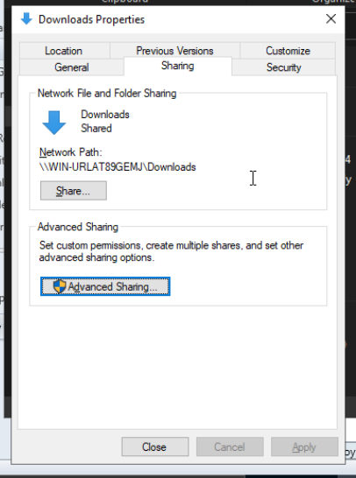

**Step 2: Open the SCCM Console**

1. Launch the **Configuration Manager Console**.
2. Navigate to:
3. Software Library > Application Management > Applications

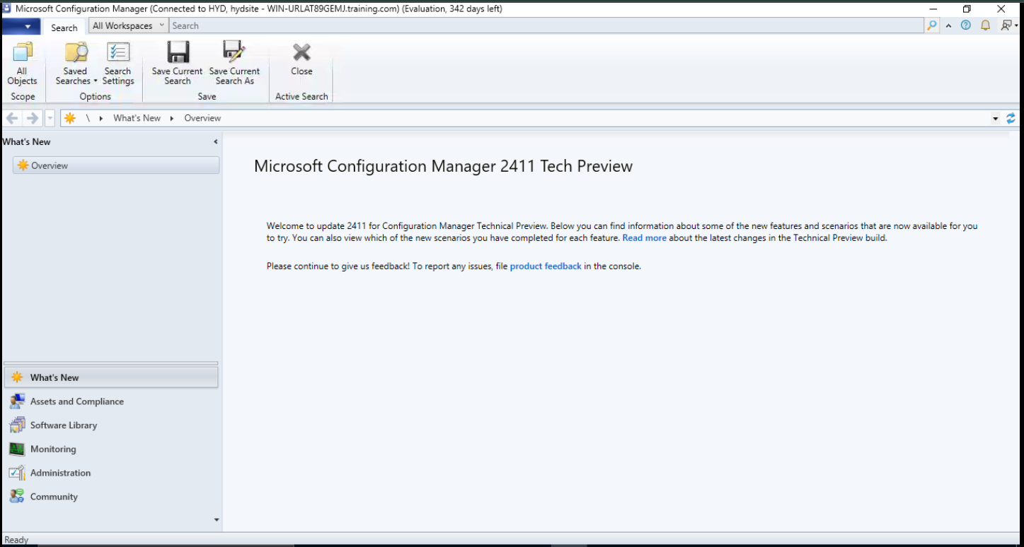

**Step 3: Create a New Application**

1. In the Home Tab, click **Create Application**.
2. Choose Automatically detect information from an installation file.
   * Select Windows Installer (*.msi file).
   * Browse to the UNC path of the MSI

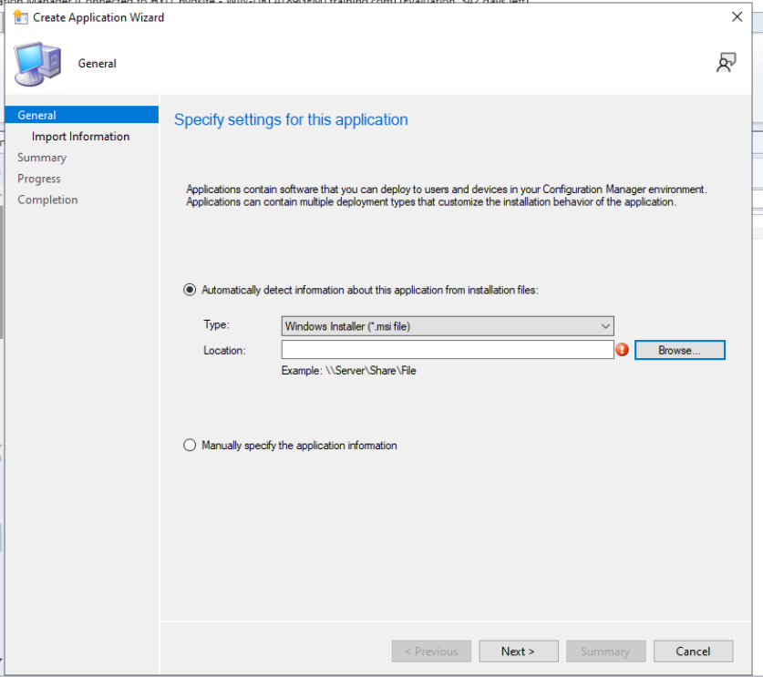

1. Click **Next**.
   * SCCM will automatically detect name, version, publisher.

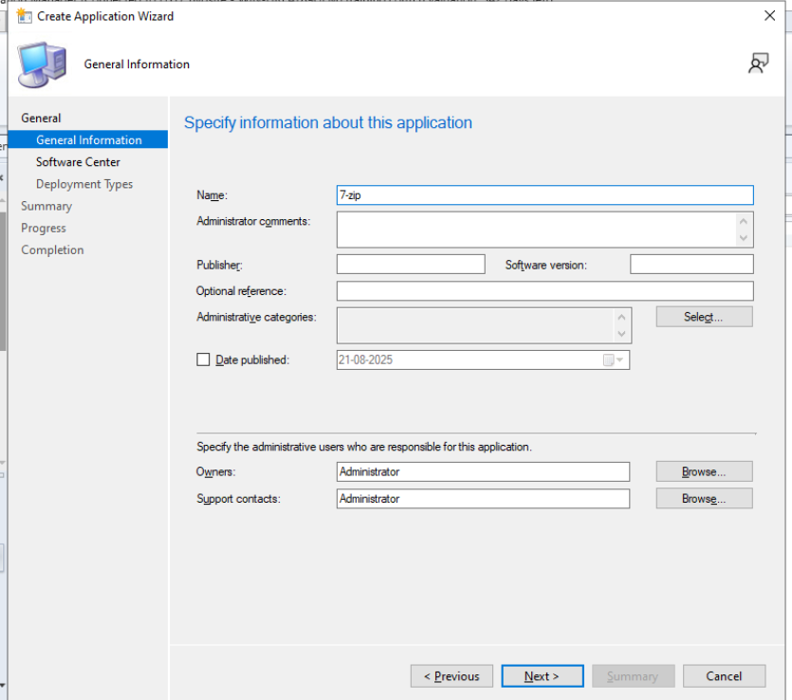

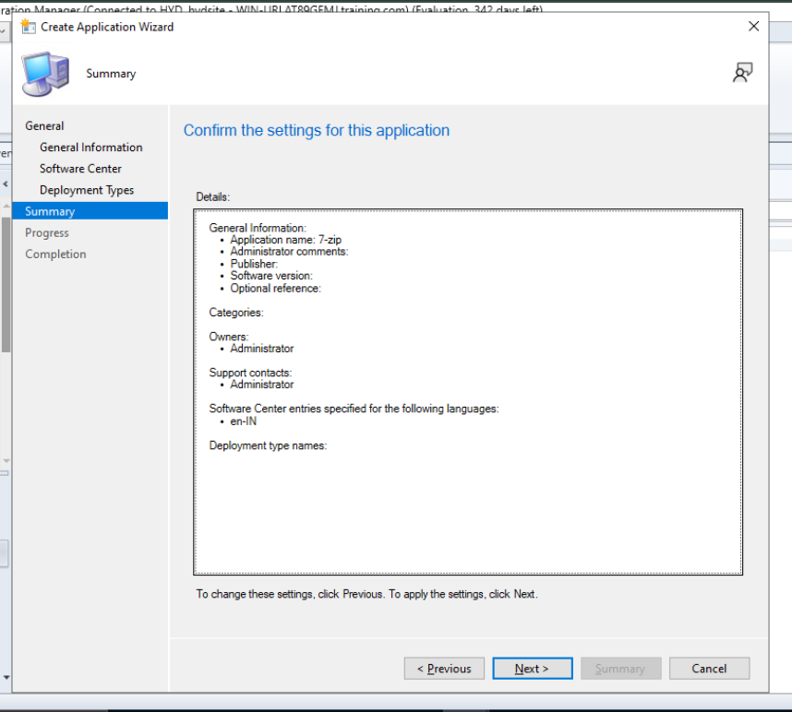

1. Finish the wizard → SCCM creates the **Application object**.

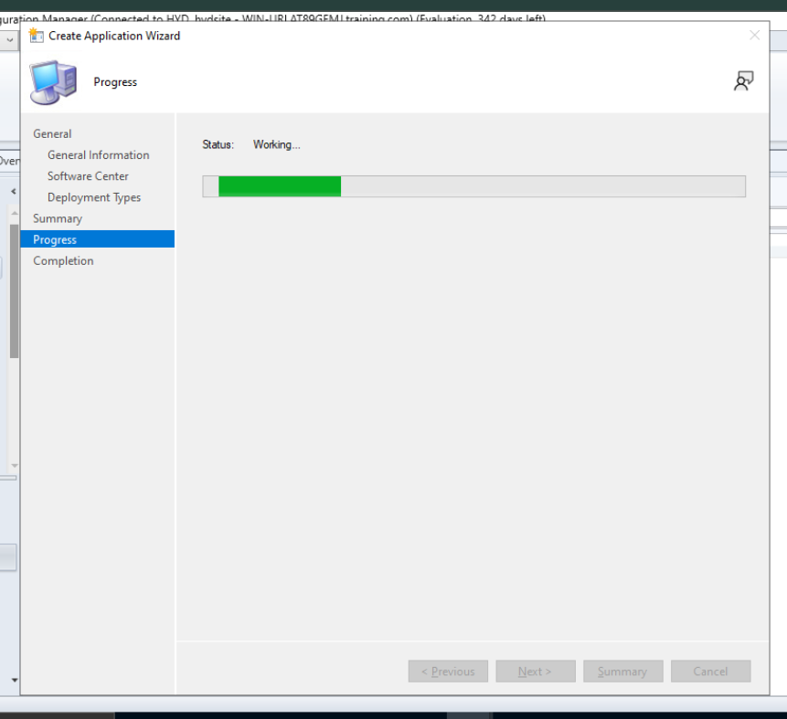

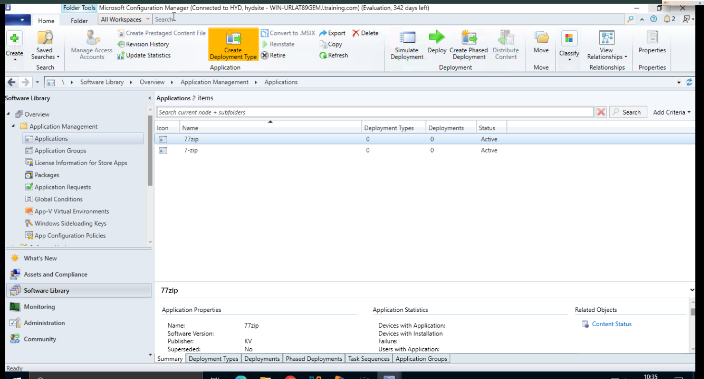

**Starting Deployment :-**

**1. Examine Application Properties**

* Select the app → **Home > Properties**.

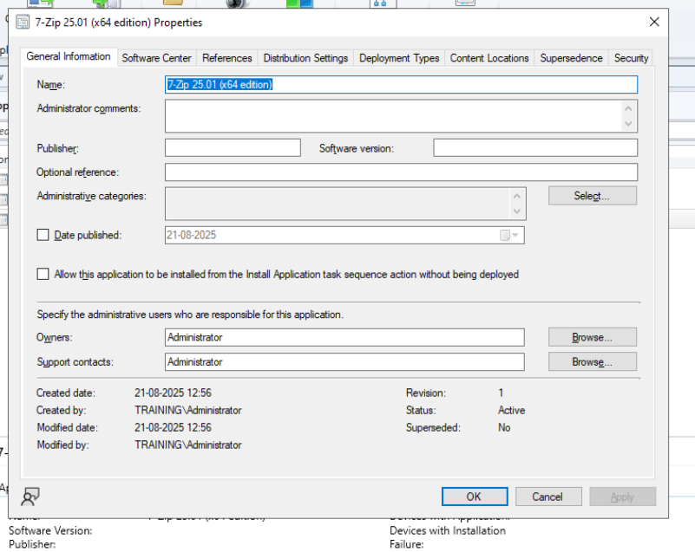

* Go to **Deployment Types** tab → select the deployment type → **Edit**.

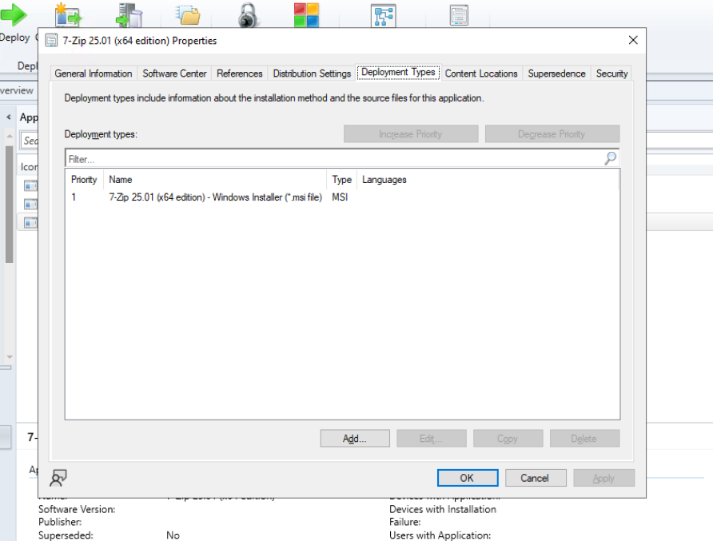

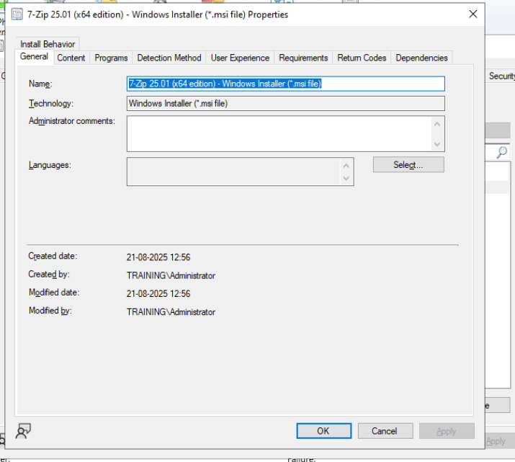

**2. Add a Requirement**

* Go to **Requirements tab** → **Add**.
* Category: Device
* Condition: Operating System
* Rule type: Value
* Operator: One of
* Select: **All Windows 10** → OK.

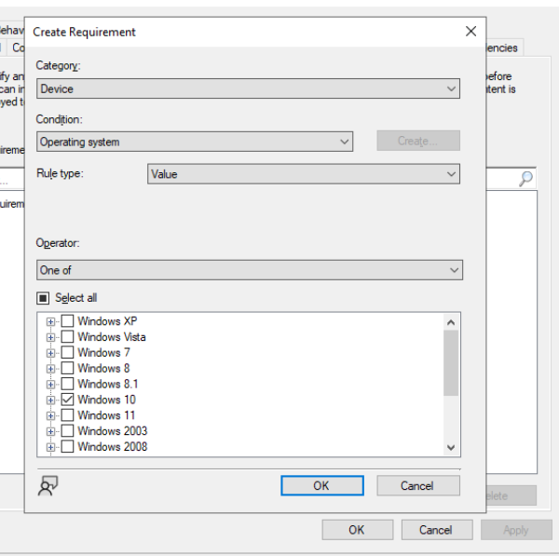

**3. Distribute Application Content**

* Go to **Software Library > Applications**.
* Select app → **Distribute Content**.
* Select the Distribution Point → Finish.
* Verify in **Monitoring > Distribution Status > Content Status**.

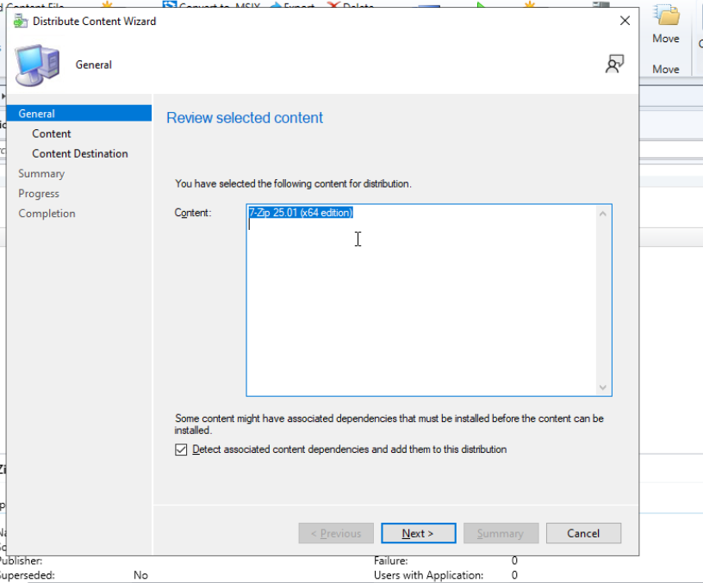

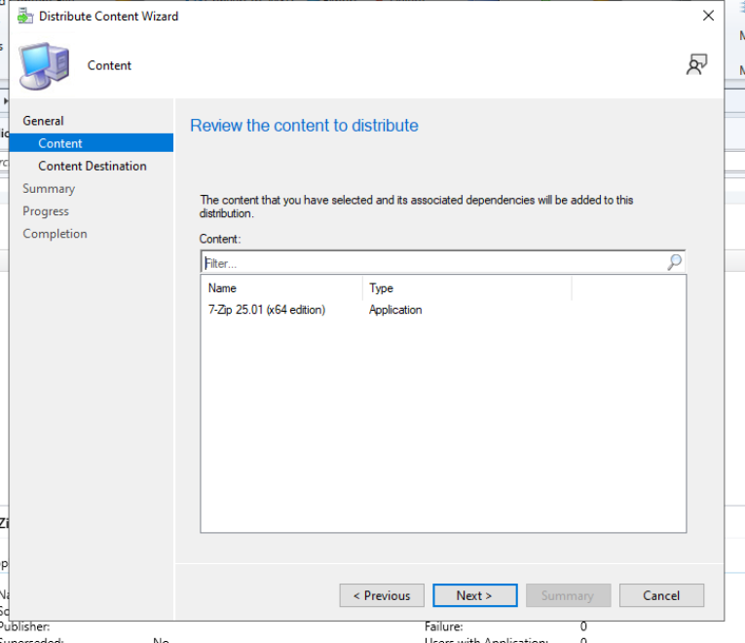

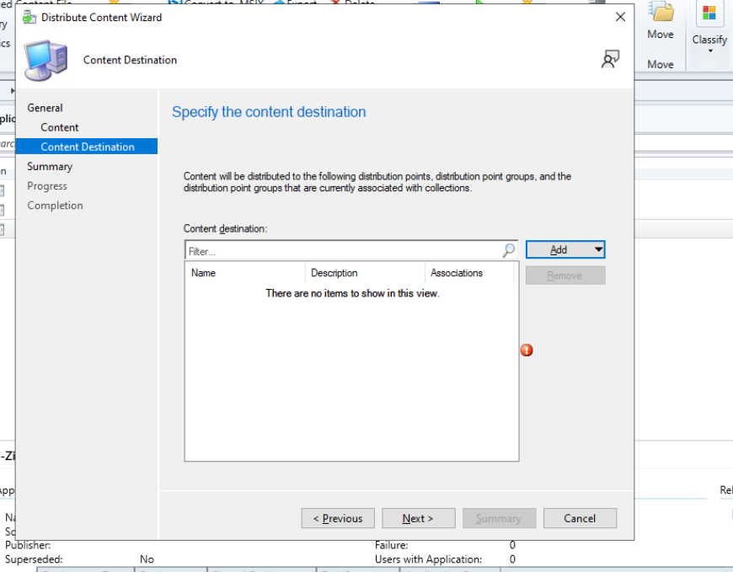

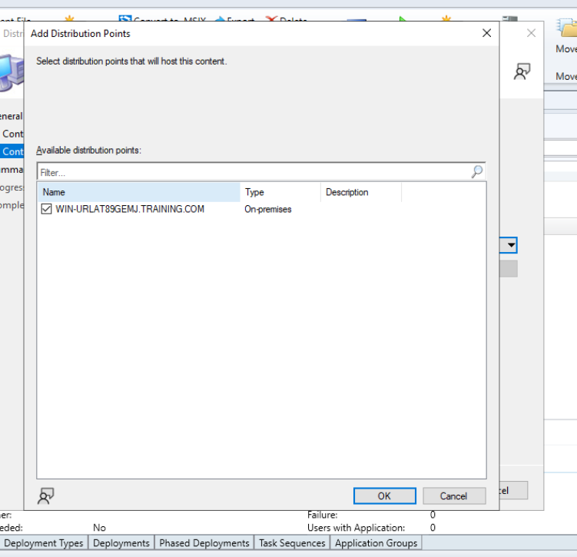

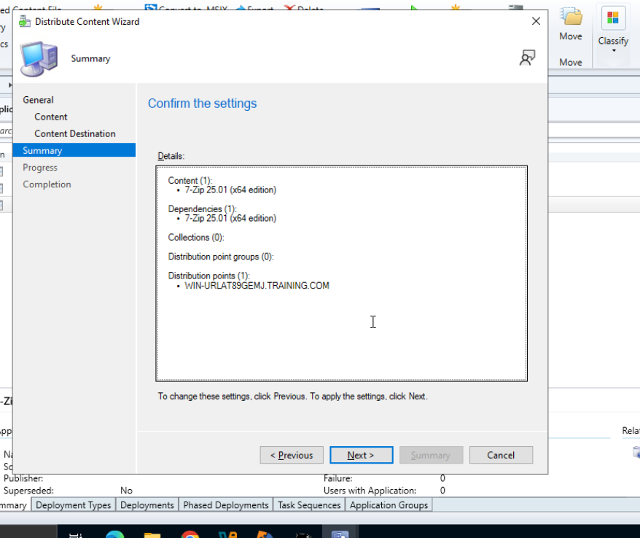

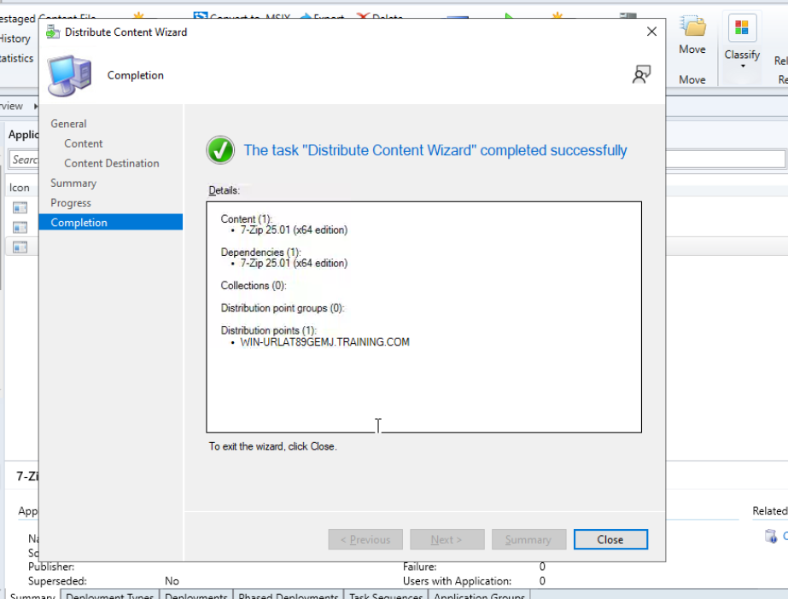

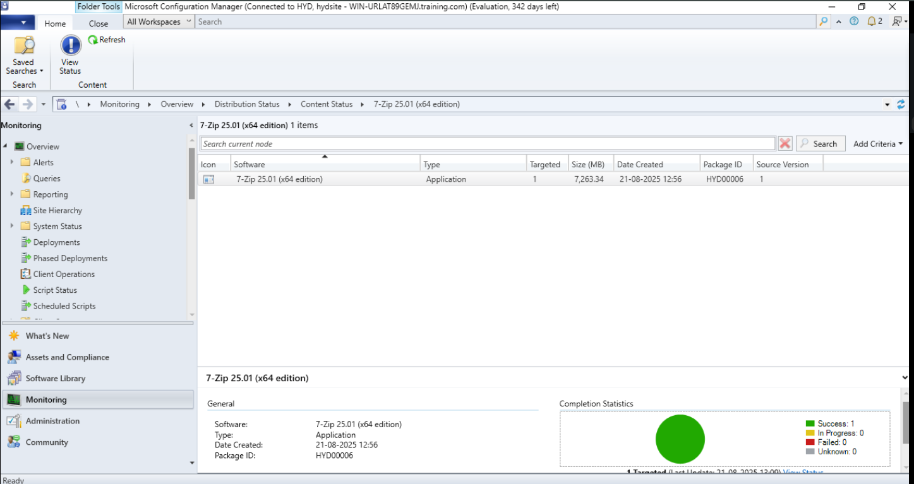

**4. Deploy the Application**

* Select app → **Deploy**.
* Target: **All Systems collection**.
* Deployment action: **Install**.
* Purpose: **Required** (auto install).
* Schedule: **As soon as possible**.
* Finish wizard.

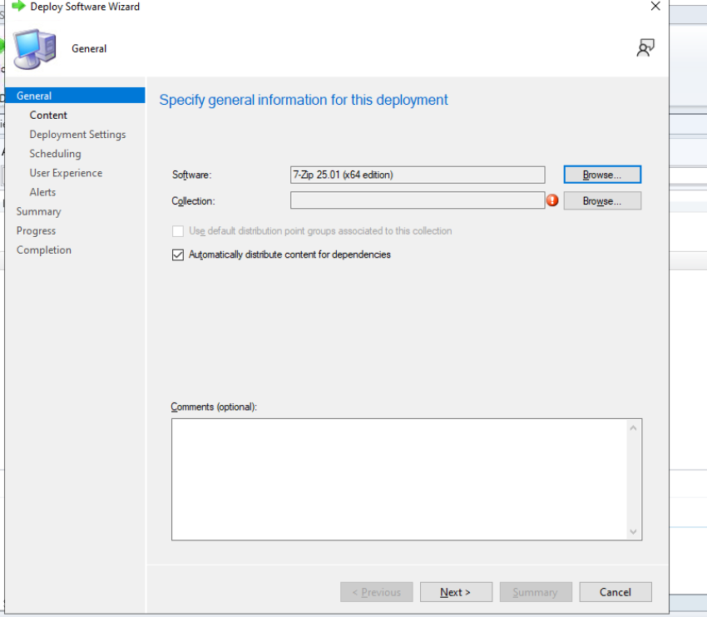

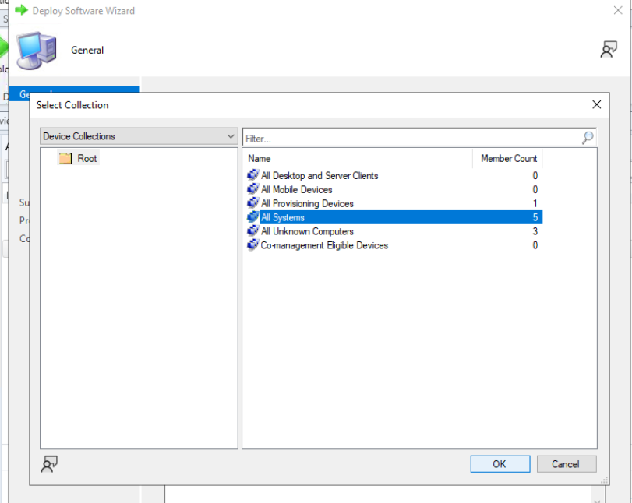

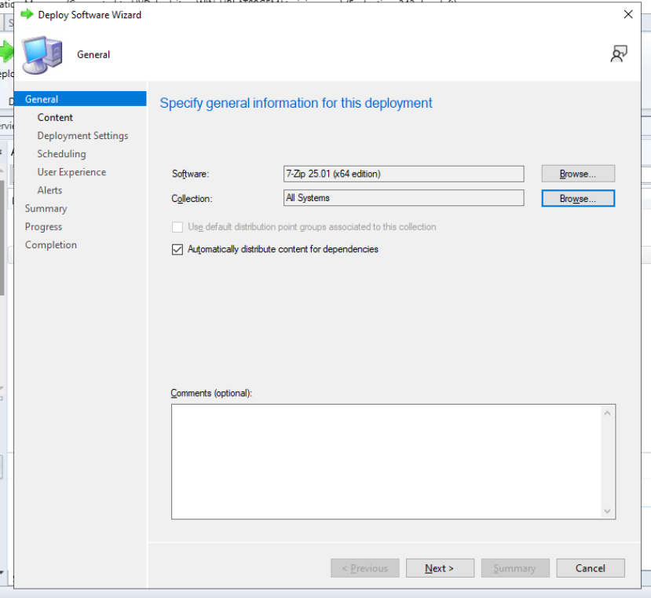

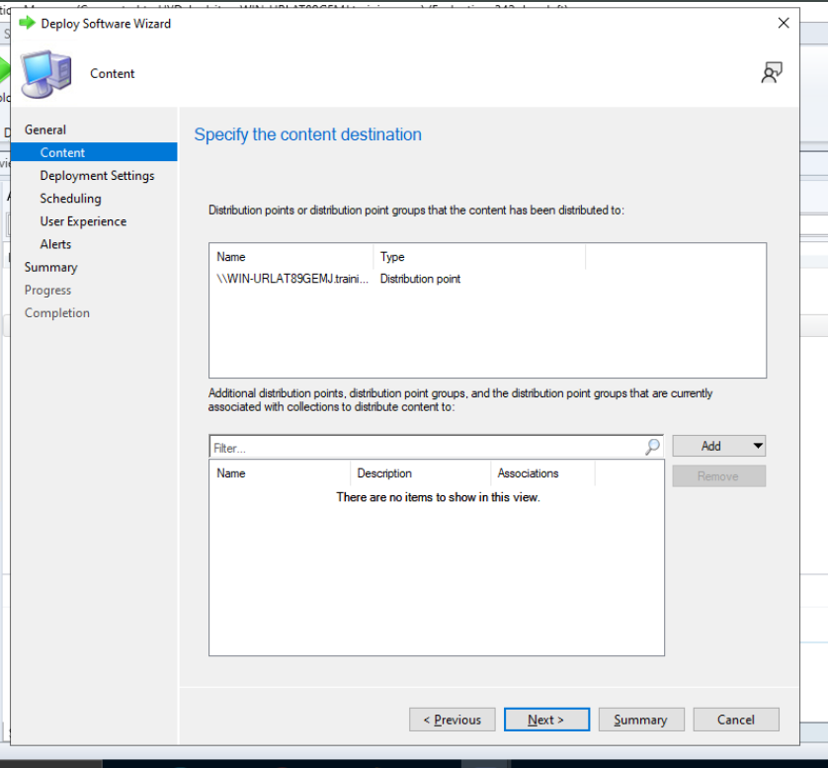

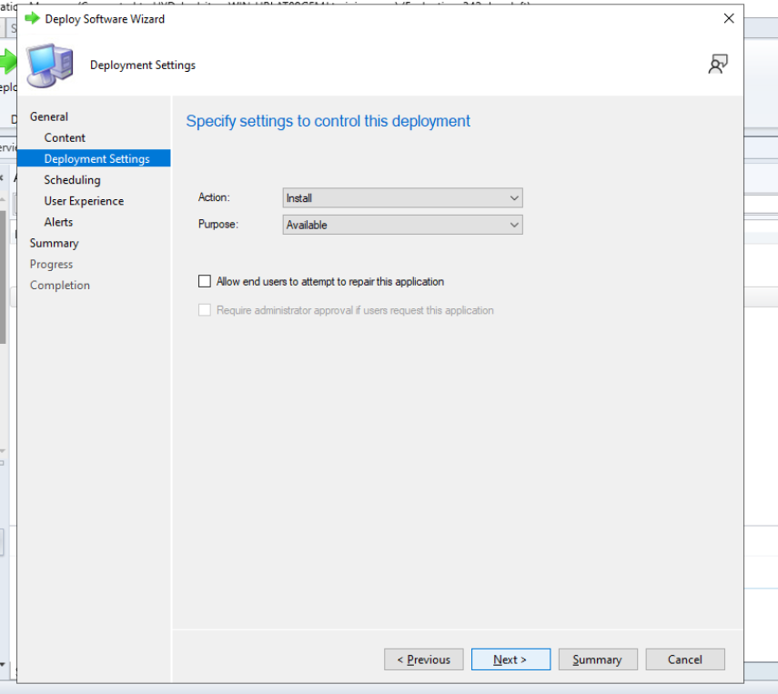

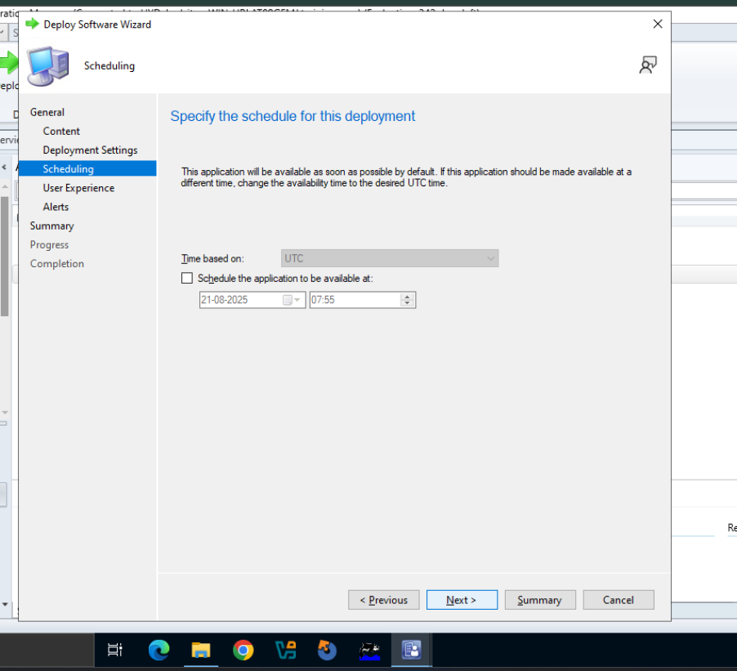

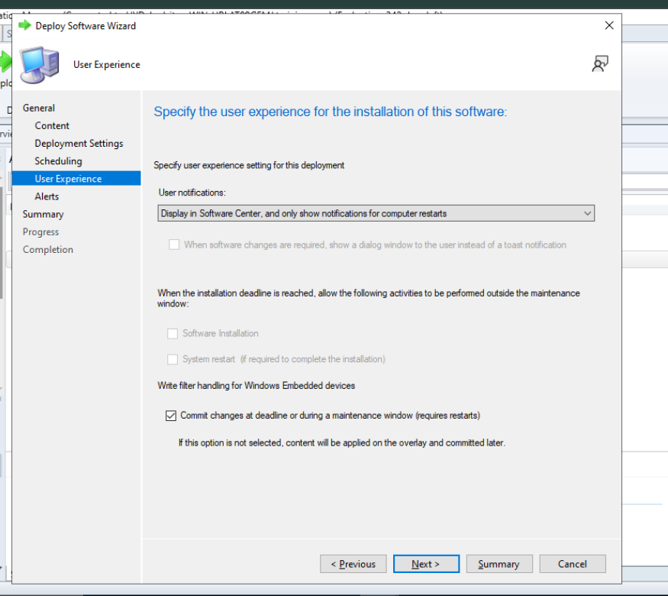

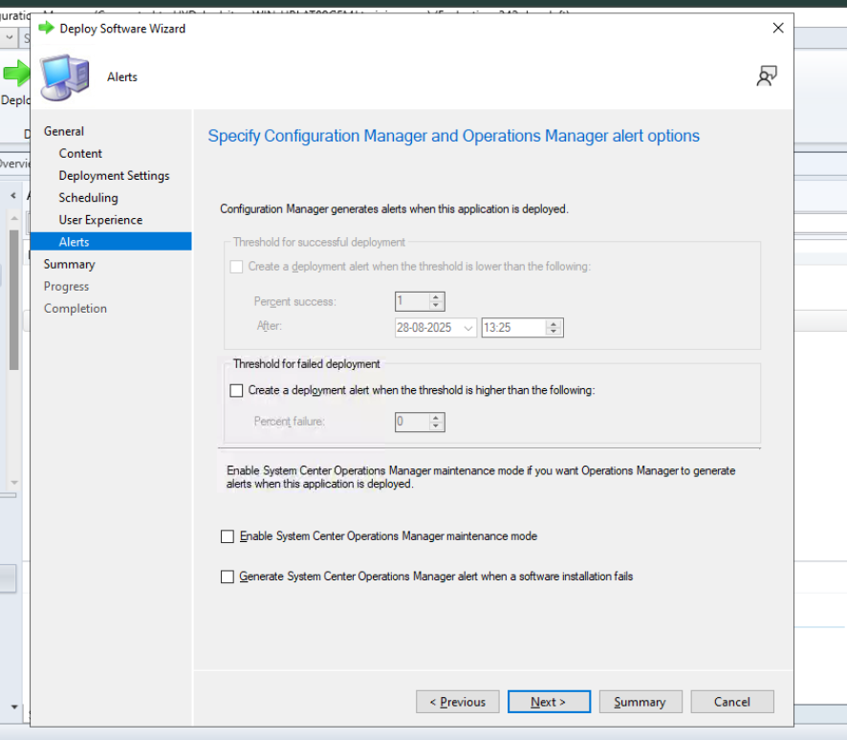

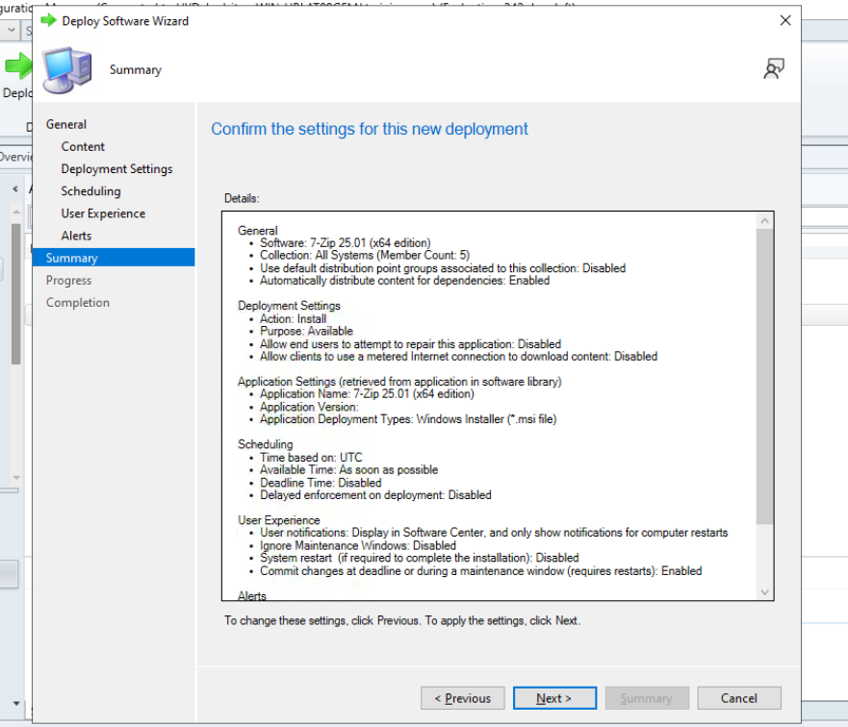

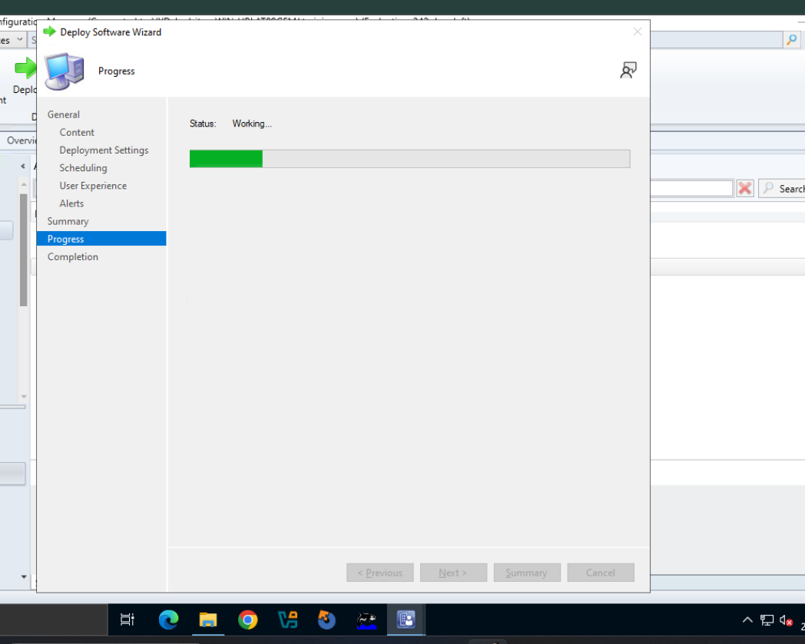

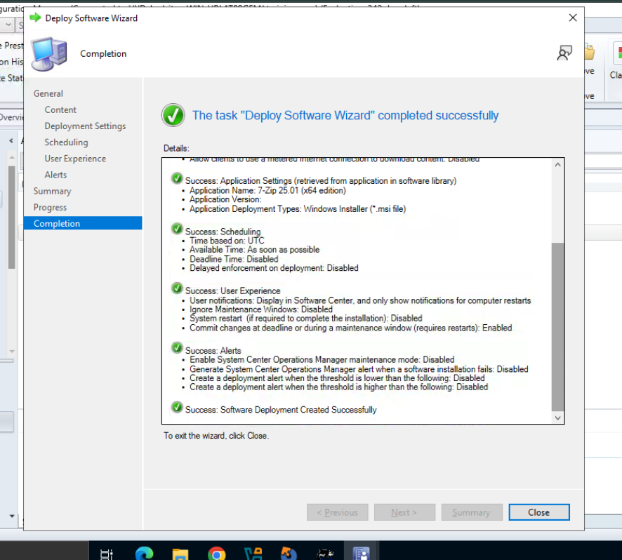

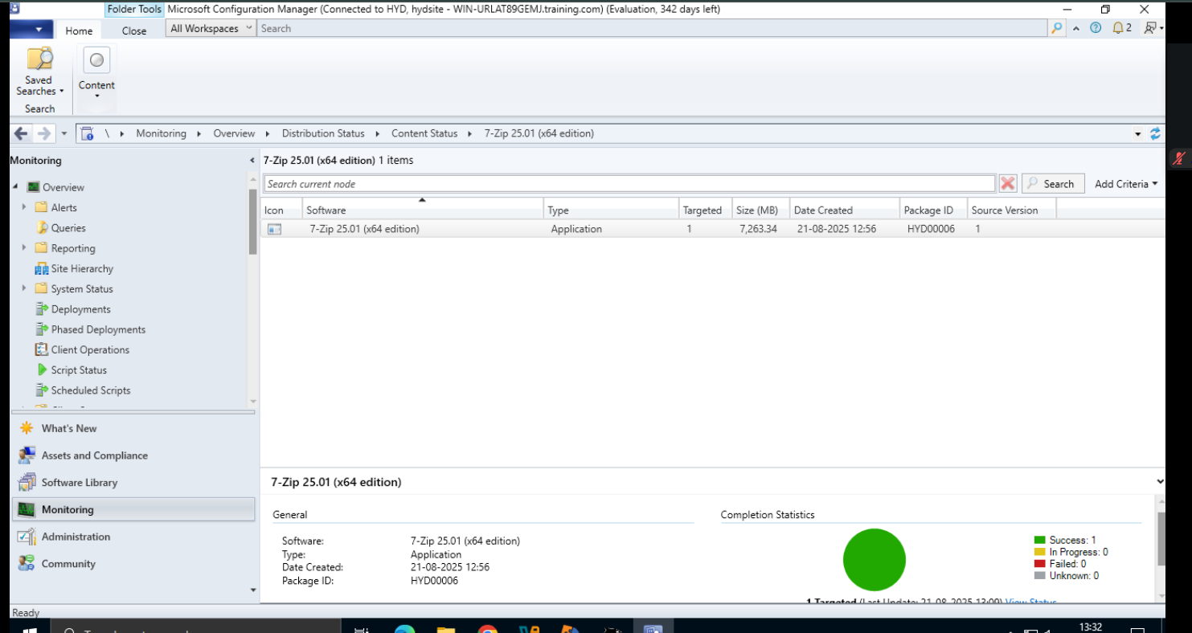

**5. Monitor Deployment**

* Go to **Monitoring > Deployments**.
* Select app → **View Status**.

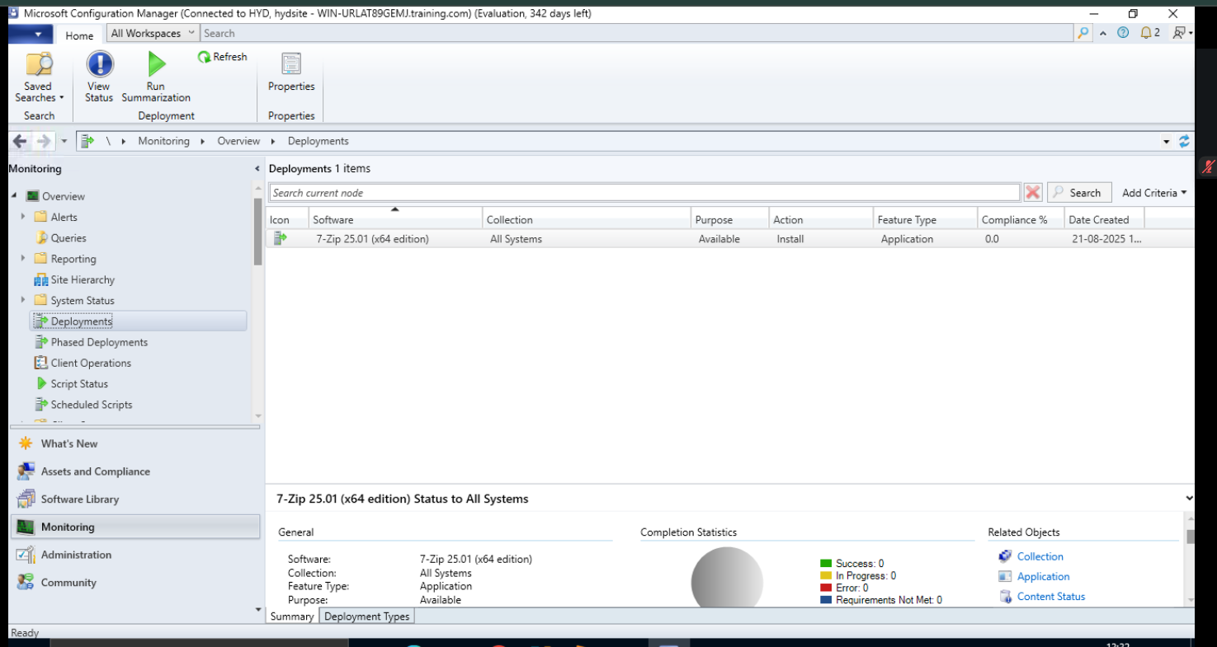

* Tabs show status:
  + Success
  + In Progress
  + Error
  + Requirements Not Met (non-Win10)
  + Unknown

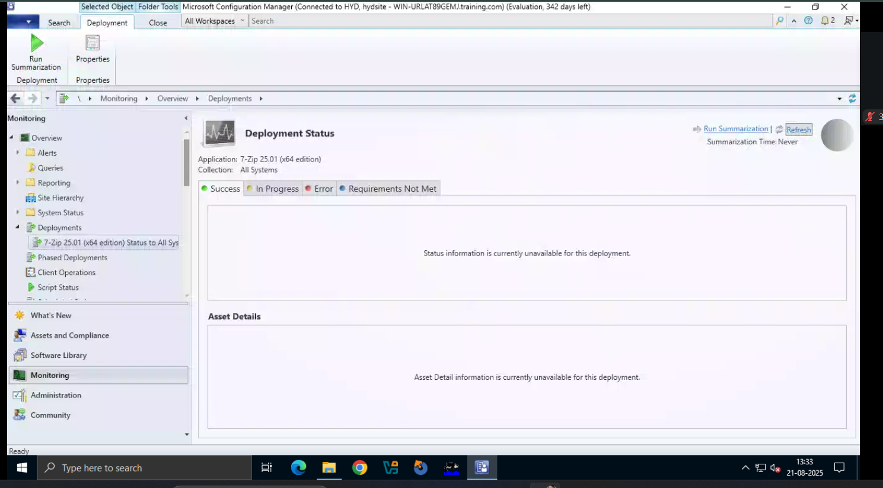

**6. User Experience**

* On Windows 10 client PCs, users see a prompt to install.
* Once accepted, installation runs automatically.